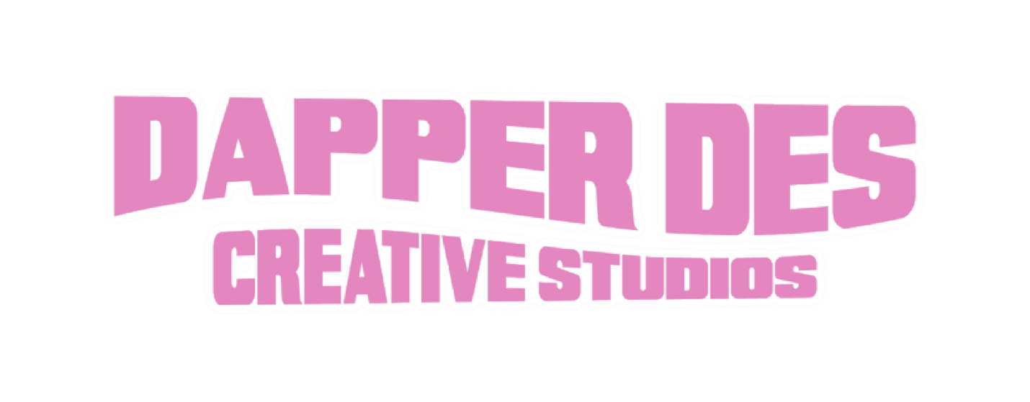
WHAT DAYS DO YOU OPERATE?
- Days of operation are Monday through Friday! We are closed on the weekends and all bank holidays.
WHAT IS YOUR COMMUNICATION POLICY?
- To keep an accurate paper trail, communications related to projects designed by Dapper Des Creative Studios must be done via email. Please allow up to 48 hours for a response to your inquiry. Emails are not typically answered on days the studio is closed.
WHAT DO I PROVIDE TO GET STARTED?
- Once your order is placed, your design project is added to the queue! You will receive an email for each order placed requesting project details. Simply reply to that email with your information, as necessary. Be as detailed as possible - include anything that will be beneficial to the design of your project (logos, HIGH QUALITY pics, wording, etc). Not being detailed enough could result in added time and costs due to revisions.
WHAT IF I WANT A REFUND?
- For design orders, once your order is placed, refunds are not permitted. Please make sure you are ready to order and that you have selected the correct service before checkout is complete. The only way a refund will be processed is if, in the rare event, the design is unable to be completed due to an issue on my end or if time has greatly exceeded the due date with no update to the project.
- For print orders, no refunds or exchanges are permitted due to the usual custom nature of the item. You may request an exchange if your project is not adequately reflective of the mockup you received.
** Please keep in mind that items may differ on the screen which you are viewing vs. real life prints due to different device resolutions**

